1. **Modern Apizza(1)**

Address - 874 State St, New Haven, CT

|  |  |
| --- | --- |
| Mon | Closed |
| Tue - Thu: | 11:00 am - 11:00 pm |
| Fri - Sat: | 11:00 am - 11:30 pm |
| Sun: | 3:00 pm - 10:00 pm |

* Photos

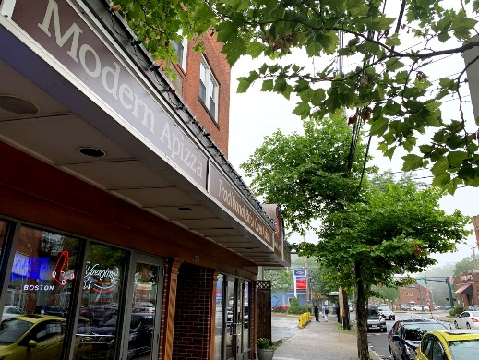 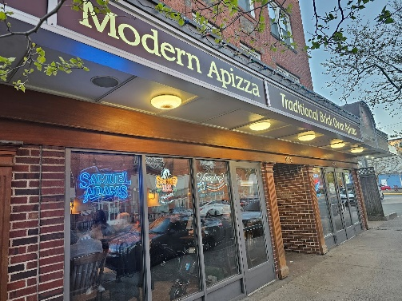

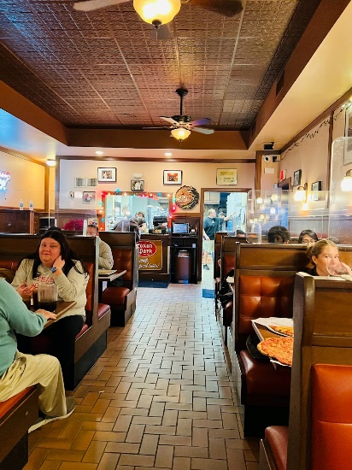 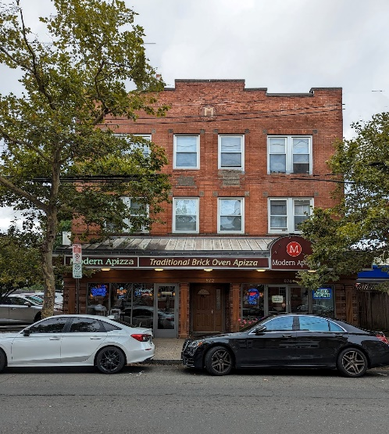

* Established – 1925
* serves traditional brick-oven pizzas, with mozzarella and American cheese bases
* Also Known as PizzaPlus
* History
* On March 4, 1911, Antonio “Tony” Tolli was born in Plainville
* then returning to America at age 18
* In 1934, Joseph Marzullo and his cousin, Antonio ToIli, opened a pizzeria down the street from Marzullo’s confectionery and called it Washington Pizzeria
* They lasted in business here for two years when Marzullo returned to his pastry shop.
* Website Detail – ( <https://www.modernapizza.com/> )
* Single page website Contains Opening hour, address, Menu and Certificates
* UI can be Improved
* Buy certificates features ( Payment Gateway )
* Website Detail – ( <https://www.pizzaplusinc.com/> )
* Single page website Contains Opening hour, address, Menu and Certificates
* Order Online features ( Payment Gateway )
* Old UI
* Application form for job, feedback

1. **Frank Pepe Pizzeria Napoletana(3)**

Address – 157 Wooster St, New Haven, CT 06511

|  |  |
| --- | --- |
| Mon - Thu | Closed |
| Fri: | 5:00 pm - 9:00 pm |
| Sat: | 1:00 pm - 11:30 pm |
| Sun: | 1:00 pm - 10:00 pm |
|  |  |

* Photos

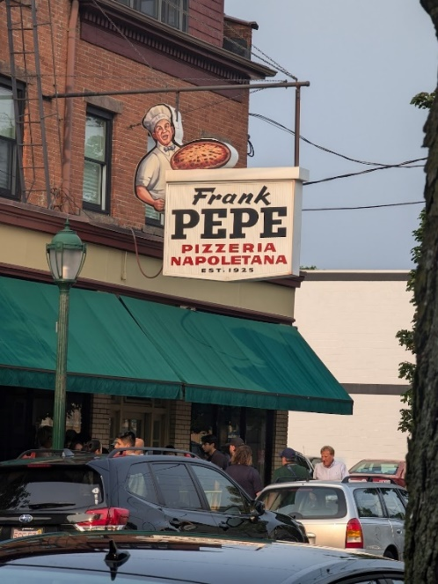 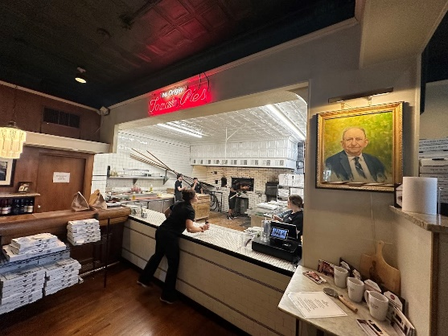

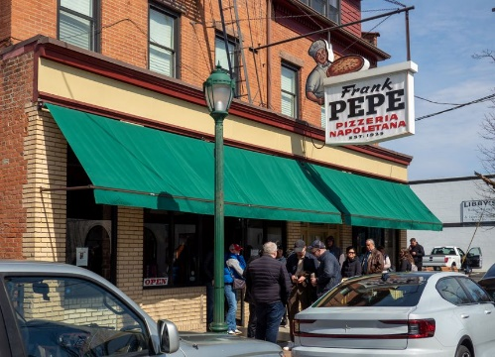 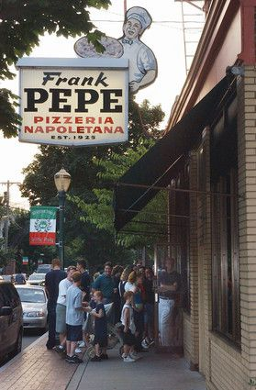

* Established – 1925
* Home to white clam pizza
* Locally known as Pepeâ??s (pep-eez)
* its Original Location in the Wooster Square neighborhood of New Haven, CT. Today, there are 14 additional locations across CT, MA, RI, NY, MD, VA, and FL
* Website details
* Currently not reachable (**www.pepespizza.com** took too long to respond.)

1. **Marco Polo Pizzeria & Italian Restaurant(16)**

**Address - 55 Crown Street**, **New Haven, CT 06510**

|  |  |
| --- | --- |
| Mon - Sat: | 10:00 am - 11:30 pm |
| Sun: | 11:00 am - 11:30 pm |

* Booking for Catering
* Italian food
* Corporate Meetings
* Birthday Parties
* Anniversaries
* Baby / Bridal Showers
* Graduations
* Corporate Lunches & Picnics
* Holiday Parties
* School Events
* Photos

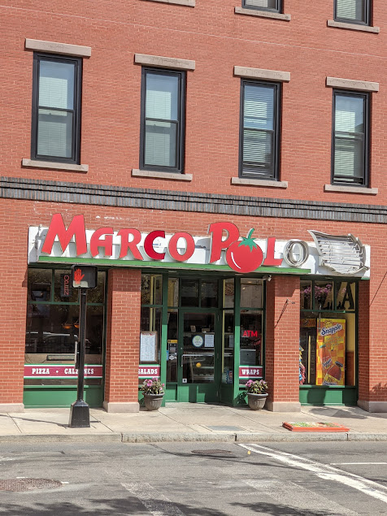 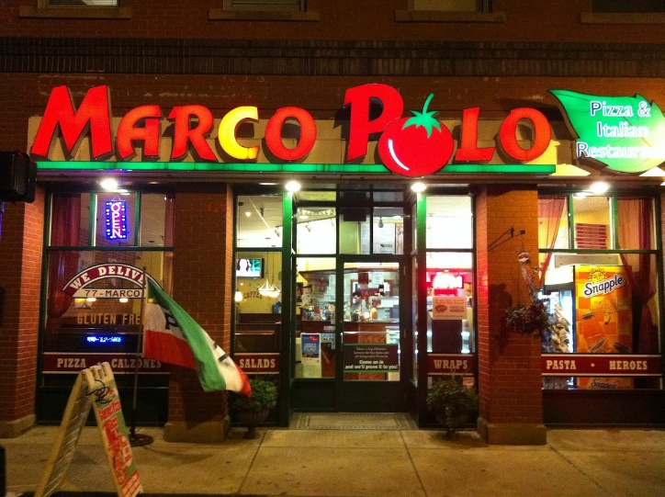

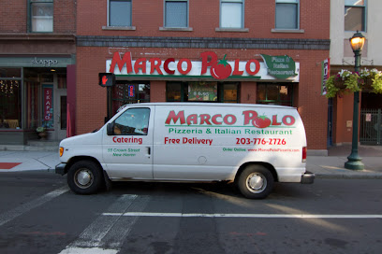 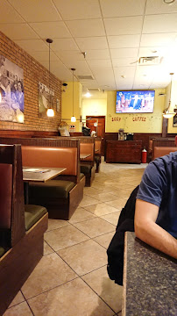

* Website Details – (https://www.marcopolopizzeria.com/)
* Very basic website with mailing service
* So many products but menu is not quite visible and readable
* Online order service available
* Created by Farron + Saifee LLC. (<http://www.farronsaifee.com/>) Whose website is also not working

1. Zeneli Pizzeria e Cucina Napoletana(2)

Address - 138 Wooster St, New Haven, CT 06511, United States

Contact - +12037454194

|  |  |
| --- | --- |
| Mon - Sun: | 11:00 am – 9:00 pm |
| Tue: | Closed |

* Photos

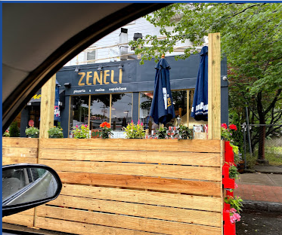 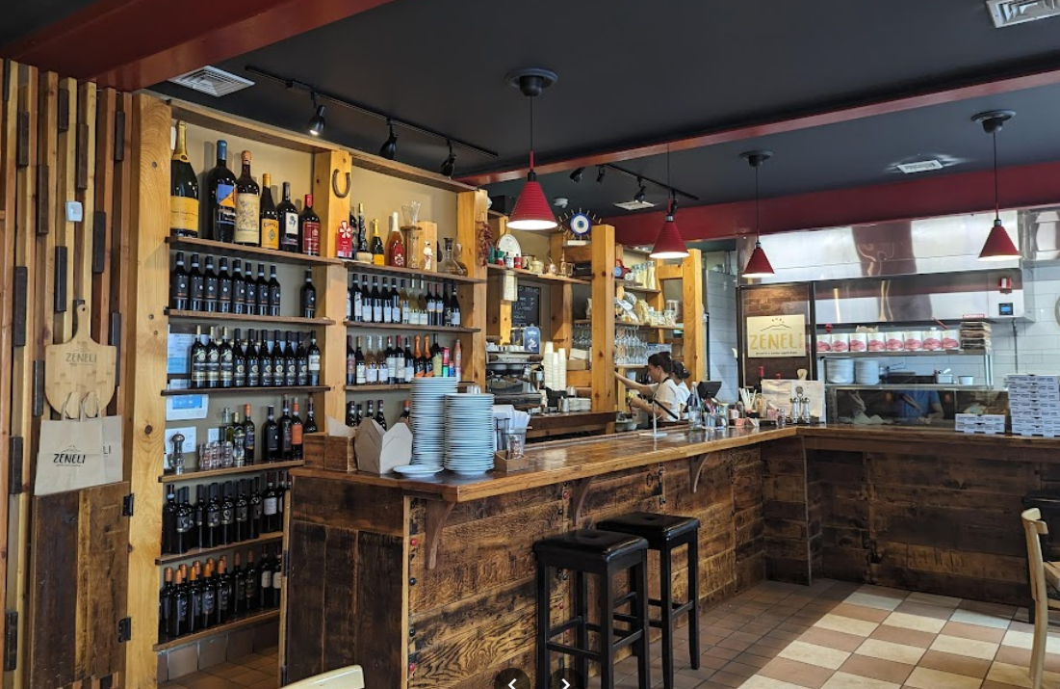

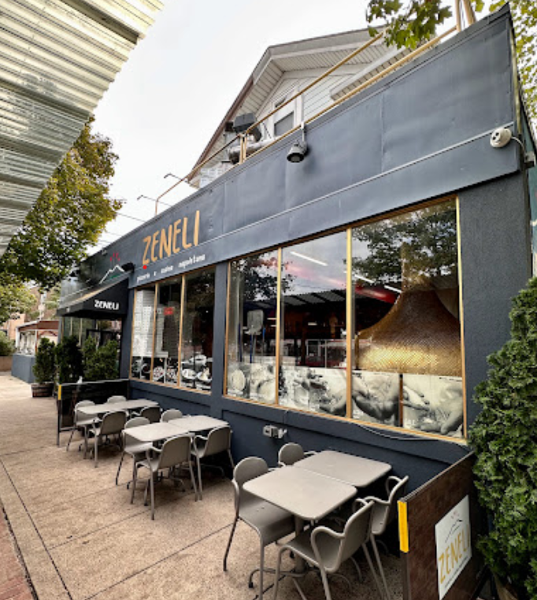 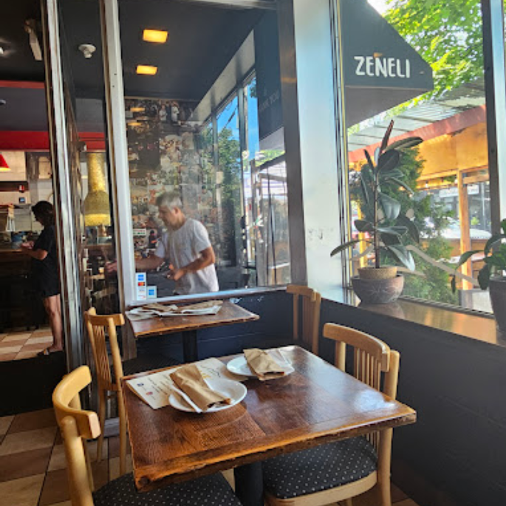

* Website Details – (<https://www.zenelipizzeria.com/>)
* Good Website but incomplete
* No navbar
* Contact Us section is missing, only heading is present
* Menu Section is proper

1. **Ernie's Pizzeria(5)**

Address - 1279 Whalley Ave, New Haven, CT 06515, United States

Contact - +12033873362

|  |  |
| --- | --- |
| Sun-Thus: | 3:00 pm - 10:00 pm |
| Friday: | 11:00 am - 11:00 pm |
| Saturday: | 12:00 pm - 10:00 pm |
| Monday: | Labor Day (Hour may differ) |

* Photos

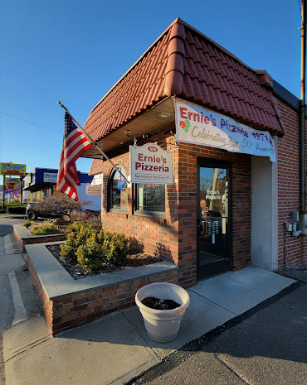 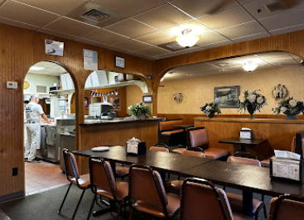

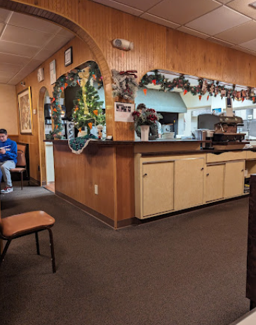 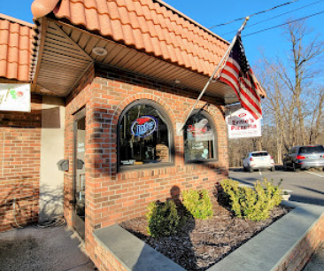

* Website details – Not Available

1. **Pizza at the Brick Oven(6)**

Address - 122 Howe St, New Haven, CT 06511, United States

Contact - +12037774444, [(203) 777-4444](tel:203-777-4444)

|  |  |
| --- | --- |
| Sun-Thus: | 3:00 pm - 3:00 am |
| Friday-Saturday: | 3:00 pm - 4:00 am |

* Photos

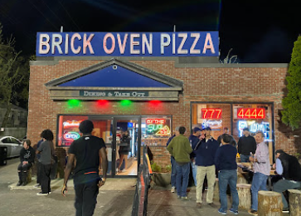 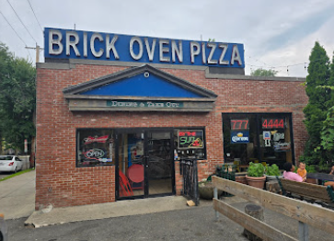

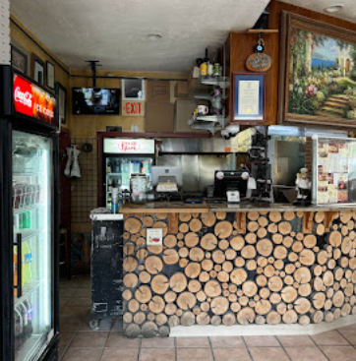 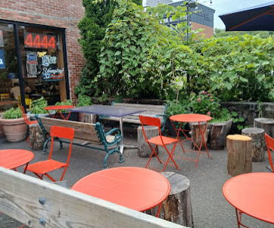

* Website Details – (<https://newhavenbrickovenpizza.com/>)
* Good Website with proper UI and animation
* Also Mobile application is available on android and iOS both
* Online order service available (Payment Gateway)